|  |  |
| --- | --- |
| |  | | --- | | **YEAR 12 Essentials Mathematics**  **Semester 2 2018**  **Investigation 3 – Compound interest** | |
| Total Marks: ______ / 22 marks  Name: ______________________ Total Time: 55 minutes |

***Full working out must be shown to get full marks.***

***Attempt all questions***

***Resources allowed:***

***1 A4 page, (1 side) of hand written notes, ruler, calculator***

Through hard work and a careful savings strategy Stevie and Macca have accumulated $10,000 each with which they are buying a car.

Stevie’s car Macca’s car

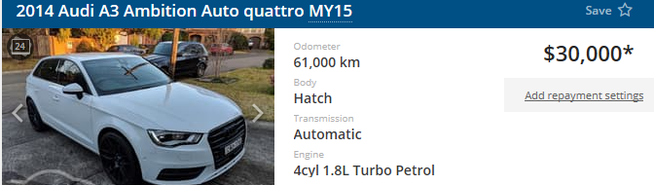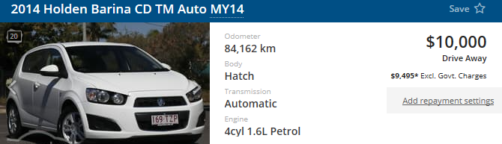

**Q1)** Macca does not have enough savings to afford car 2 so he will need to organise finance using a 5 year loan for the extra money that he will need. Using the comparison rate below, calculate the total cost of purchasing the $30,000 car if the loan is compounded monthly (answer to 2 d.p.)



2 Marks

**Q2**) Macca will need to ensure he pays back the total cost over the 5 years. Calculate how much he will need to pay fortnightly in order to pay off the total cost. *(26 fortnights in a year -* answer to 2 d.p.)

1 Mark

**Q3)** Unlike bank accounts that gain value over time, cars lose value over time. We call this reverse interest “depreciation”.

Use the formula below to calculate the amount of money each car loses over 5 years if each car loses 10% of its value each year.

* the formula for depreciation is **D = P(1 - $\frac{r}{n})^{t}$.**

*Stevie’s car:*

2 Marks

*Macca’s Car:*

2 Marks

Use the answers above to fill in the able below.

|  |  |  |
| --- | --- | --- |
|  | Stevie’s car | Macca’s car |
| Initial value |  |  |
| Total cost of purchase |  |  |
| Car’s value after 5 years |  |  |
| Total cost – Cars current value = |  |  |

2 Marks

**Q4)** From his regular pay, Stevie is able to save $500 per fortnight, how much is this per year?

1 Marks

**Q5)** Originally Macca was able to save the same amount as Stevie each fortnight, but now he also needs to pay back his car loan. How much will Macca now be able to save per annum? ***(saving – repayment)***

2 Marks

**Q6)** Over the 5 years that Macca has the loan, how much more will Stevie be able to save than Macca?

2 Marks

**Q7)** Stevie and Macca decide to invest their 5 year savings into two different accounts. Stevie invests in a 5% compounding account for 10 years (compounded monthly). Macca invests in a 6.5% simple interest account. What would be the end value of their respective accounts (answer to 2 d.p.)?

Stevie

2 Marks

Macca

2 Marks

**Q8)** From when Macca and Stevie bought their cars to now, who has made better finical decisions? ***Comment on their total wealth, savings, and investment choices.***

4 Marks

**End of Investigation**